**Practical:- 1**

**Aim:-** Write a HTML page to print Hello World in bold and italic font.

<!DOCTYPE html>

<html>

<head>

<title>

Practical_1

</title>

</head>

<body>

<p><b><i>Hello world</i></b></p>

</body>

</html>

# Output:-

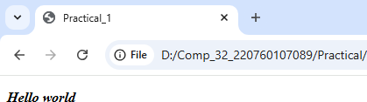

## **Practical:-2**

## **Aim:-** Display various text formatting methods available in HTML.

<!DOCTYPE html>

<html>

<head>

<title>

Practical_2

</title>

</head>

<body bgcolor="silver">

<h1><b><u>Harshil Patel</u></b>

<br>

</h1>

</body>

</html>

# Output:-

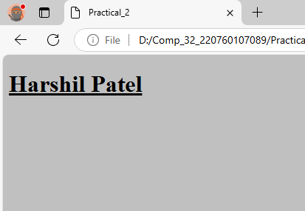

## **Practical:- 3**

## **Aim:-** Create a HTML file using special characters.

<!DOCTYPE html>

<html>

<head>

<title>

Practical_3

</title>

</head>

<body>

<p><blink><font color="red" size="15"><mark>Spacial symbol</mark></font></blink></p>

<p>&amp;</p>

<p>&copy;</p>

<p>&hearts;</p>

</body>

</html>

# Output:-

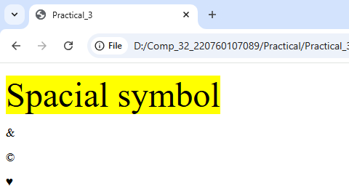

**Practical:- 4**

## **Aim:-** Create a HTML file which displays 3 images at LEFT, RIGHT and CENTER respectively in the browser<!DOCTYPE html>

<!DOCTYPE html>

<html>

<head>

<title>

Practical_4

</title>

</head>

<body>

<p align="left"><img src="p4_image1.jpg" alt="p4_image1"></p>

<p align="center"><img src="p4_image2.jpg"alt="p4_image2"></p>

<p align="right"><img src="p4_image3.jpg" alt="p4_image3"></p>

</framesets>

</body>

</html>

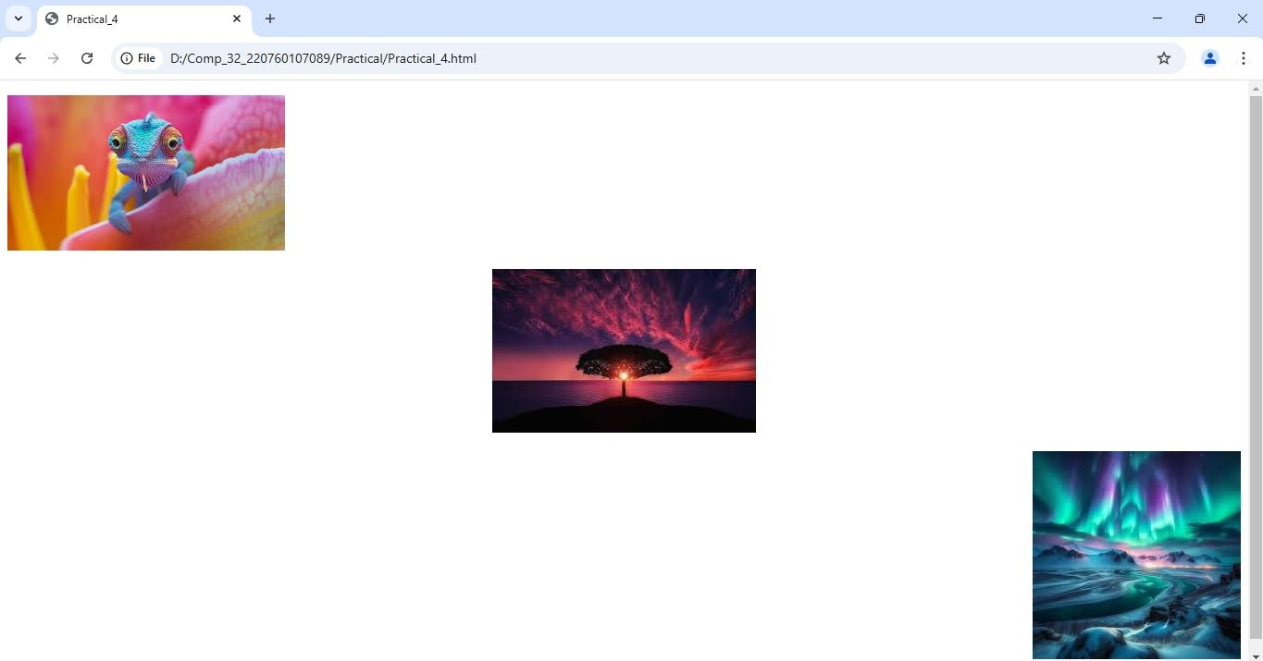**Output:**

**Practical:- 5**

**AIM:-** Create a HTML file which contains hyperlinks

<!DOCTYPE html>

<html>

    <head>

        <title>

            Practical_5

        </title>

    </head>

    <body>

        <p align="center"><a href="https://www.flipkart.com/">Flipkart</a></p>

        <hr>

        <p align="center"><a href="Practical_4.html" target="_blank">Practical_4.html</a></p>

        <hr>

        <p align="center"><a href="top.html" target="_blank">Link3</a></p>

    </body>

</html>

**Output:-**

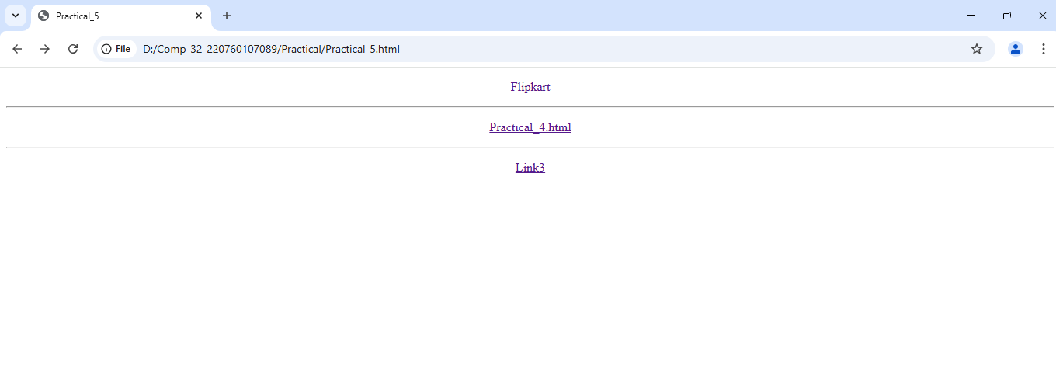

## **Practical:- 6**

## **AIM:-** Table of Contents Chapter 1: Introduction

## Chapter 2: What is HTML?

## Chapter 3: What is Javascript?

## By clicking on the link takes to the respective topic within the same page.

## <!DOCTYPE html>

## <html>

## <head>

## <title>

## Practical_6

## </title>

## </head>

## <table border="2">

## <tr>

## <th><b>Chapter</b></th>

## <th><b>Topic</b></th>

## </tr>

## <tr>

## <th>Chapter 1</th>

## <th><a href="6.intro.html">Introduction</a> </th>

## </tr>

## 

## <tr>

## <th>Chapter 2</th>

## <th><a href="6.2.html">What is HTML?</a> </th>

## </tr>

## <tr>

## <th>Chapter 3</th>

## <th><a href="6.3.html">What is Javascript?</a> </th>

## </tr>

## </table>

## </html>

## **Output:-**

## 

## **Practical:- 7**

## **AIM:-** Create a HTML page as given below

## List of Subjects

## 1. Computer Engineering Department

## a. Software Engineering

## b. Information Security

## c. Computer Graphics

## 2. Electrical Engineering Department

## • Electrical Machine

## • Power Electronics

## • Micro Controller

## 3. Computer Engineering

## Is a discipline that integrates several fields required to develop computer systems.

## <!DOCTYPE html>

## <html>

## <head>

## <title>

## Practical_7

## </title>

## </head>

## <body>

## <h1>List of subject</h1>

## <ol>

## <li>Computer Engineering Department

## <ol type="a">

## <li>Software Engineering</li>

## <li>Information Security</li>

## <li>Computer Graphics</li>

## 

## </ol>

## 

## </li>

## <li>Engineering Department

## <ul>

## <li>Electrical Machine</li>

## <li>Power Electronics</li>

## <li>Micro Controller</li>

## </ul>

## </li>

## <li>Computer Engineering

## <dd>Is a discipline that integrates several fields required to

## develop computer systems.</dd>

## </li>

## </ol>

## </body>

## </html>

## **Output:-**

## 

## **Practical:- 8**

## **Aim**: Create table with ROWSPAN and COLSPAN attribute of TABLE in HTML (Prepare timetable of your class).Include CELLSPACING &amp; CELL PADDING

## <!DOCTYPE html>

## <html>

## <head>

## <title>

## Practical_8

## </title>

## </head>

## <body>

## <table border="1">

## <tr>

## <th>Day & time</th>

## <th>9-10</th>

## <th>10-11</th>

## <th>11-12</th>

## <th>12-1</th>

## <th>1-2</th>

## </tr>

## <tr>

## <td>Monday</td>

## <td>aj</td>

## <td>MPI</td>

## <td>WP</td>

## <td rowspan="5">BREAK</td>

## <td>IOT</td>

## </tr>

## <tr>

## <td>Tuesday</td>

## <td colspan="2">IOT</td>

## <td>TOC</td>

## <td>MPI</td>

## </tr>

## <tr>

## <td>Wednesday</td>

## <td>IPDC</td>

## <td colspan="2">AJ</td>

## <td>WP</td>

## </tr>

## <tr>

## <td>Thersday</td>

## <td colspan="3">MPI</td>

## <td>IOT</td>

## </tr>

## <tr>

## <td>Fridat</td>

## <td>IOT</td>

## <td>TOC</td>

## <td>MPI</td>

## <td>WP</td>

## </tr>

## <tr>

## <td>Saturday</td>

## <td colspan="5">Holiday</td>

## </tr>

## </table>

## </body>

## </html>

## **Output:**

## 

## **Practical:- 10**

## **AIM:** Create a simple form that will show all the INPUT METHODS available in HTML.

## <!DOCTYPE html>

## <html>

## <head>

## <title>

## Practical_10

## </title>

## </head>

## <body>

## <form action="">

## <fieldset>

## <legend>User detail</legend>

## Name: <input type="text" placeholder="Enter Your Name" required><br><br>

## Contact no. <input type="number" placeholder="Enter Your Mobile number" required><br><br>

## Password: <input type="password" name="password" placeholder="Enter Your Password" required > <br><br>

## Gender: <input type="radio" name="Gender">Male <input type="radio" name="Gender">Female <br><br>

## Address: <input type="text" placeholder="Enter your current adress"> <br><br>

## City: <select name="City">

## <option value="select Your City">Select your city</option>

## <option value="Surat">Surat</option>

## <option value="Bharuch">Bharuch</option>

## <option value="Vadoadara">Vadodara</option>

## <option value="Ahmadabad">Ahmadabad</option>

## <option value="Amreli">Amreli</option>

## </select> <br><br>

## <input type="checkbox" name="" id="" required> agree to Trem & Condition <br><br>

## <input type="submit" value="submit">

## </fieldset>

## </form>

## </body>

## </html>

## **Output:-**

## 